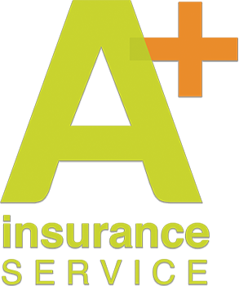

Insurance Production Manager Skills Quiz

Name:
Phone:
Email:

- What are the dates for open enrollment for Medicare ages over 65?

- What is the deadline for individual enrollment with an effective date of Jan. 1?

- When can you buy a small group policy? Large group?

- How would you create a universal price change in an Excel spreadsheet to feed multiple worksheets or workbooks?

- Jessica bought a dress that was originally $68.00. The sales tax is 8.5% but she had a 20% off coupon. How much did Jessica pay for the dress?

- What are the maximum days that an employer can add a new hire to a group plan?

- What type of plan should be in place order for an employer to be able to deduct pretax payroll for an employee portion of insurance?

- What can be a qualifying event for COBRA eligibility?

- What are the three top content marketing platforms effective for insurance agencies?

- What is the primary enrollment platform that is most popular with California insurance agencies?

When you complete the quiz, please attach it to an email and send it to: APlusInsuranceSkills@gmail.com

