**Automotive Cosmetic Repair Technician Skills Quiz**

Name:

Email Address:

Phone Number:

1. True or False: In responding to a frustrated customer's question, it's a good idea to immediately offer a solution
2. If the number or word in Column A is the same as the one in Column B, circle both items. If they are not the same, draw a line through each.

Column A Column B

10294 10294

56870 56780

39417 39417

62583 62583

41095 40159

86901 86901

23456 24365

1. If you are unable to reach someone by email, what other methods could you use?
2. Write the time below the image:

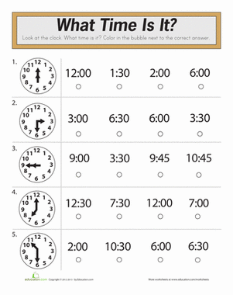

1. (100-35) +65 = ___________________
2. 34

+57

**When you are finished, please attach it to an email and send it to:** [**automarketskills@gmail.com**](mailto:automarketskills@gmail.com)